Directions to Belfast Hilton, 4 Lanyon Place Belfast

The nearest airport to the Hilton Hotel, Belfast is George Best Belfast City Airport. This is approximately 4km from the Hilton Hotel Belfast. Belfast International Airport is approximately 32km to Belfast City Centre.
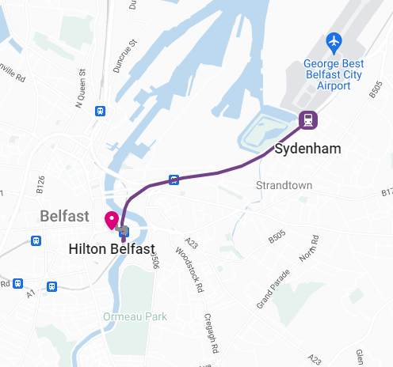
By Car / Taxi:
It takes 12 Minutes to travel from Belfast City Airport to Hilton Belfast. Fares are approximately £8-10.

By Train:
Translink UK operates a train from Sydenham to Belfast Lanyon Place hourly. Sydenham train platform is 5mins walk from the Belfast City Airport by crossing the bridge over the Sydenham Bypass. Tickets cost £4 - £6 and the journey takes 7 min.

By Bus:
Translink UK operates a bus from Belfast Knocknagoney Tesco to Belfast Lanyon Place every 30 minutes. This is approximately 10 minutes’ walk from the airport. Tickets cost £3 and the journey takes 17 min.

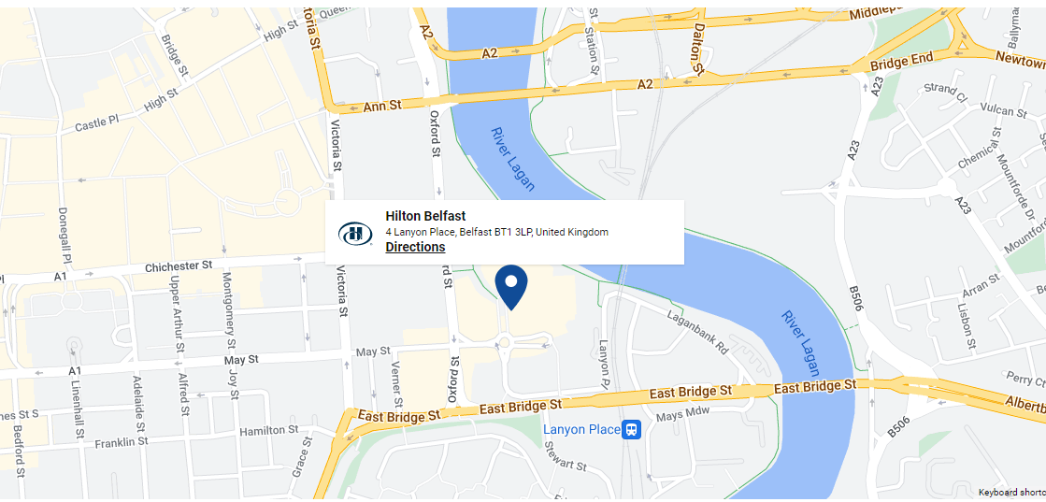
Lanyon place bus / train station is a few minutes’ walk to Belfast Hilton Hotel. Cross the road and turn left. After a few hundred meters take the pedestrian bridge to the right and it will take you to the Hilton.

